The most unbias, Political newsletter you’ve seen
  - Volume 1 / Issue 1
In this issue
In this issue, you will learn which political sources are better than others. One will also be learning why they should vote, what an irrational voter is, campaign techniques and tricks that you can avoid falling subject to, and hopefully result in becoming a responsible rational voter.

God bless America, that its voters will be rational

What is rational voting?
Every American should strive to become a rational voter. What this means is doing the research on political candidates and picking the candidate most relevant to your political opinions.

What is Irrational Voting?
Irrational voting can be deemed as the opposite of rational voting. One irrational voting for a political candidate may choose to vote for the candidate because their hair color is the same, they have good style, their race it the same, simply put; choosing a candidate with irrelevant similarities that do not support your political view.

Q: How do you know if you voted irrationally?
A: If you voted and you didn’t do any research on any of the candidates, there’s a good chance you voted irrationally.

Q: What if I don’t want to vote?
A: It’s every American citizen’s right and duty to vote for the leaders of their country. If your opinion isn’t counted for, others with similar interests would be misrepresented and campaign results wouldn’t be as accurate as America truly demands.

“Nobody will ever deprive the American people of their right to vote except the American people themselves and the only way they could do that is by not voting.”

– Franklin D. Roosevelt

The right to vote
We often take the right to vote as granted. Below are a few resons from,http://www.safetyandjustice.org/files/Top%20Reasons%20to%20Vote%20-%20Handout-3.pdf.

Your vote is your voice. When we vote, we are actually telling elected officials and lawmakers how we feel about education, public safety, social security, health care, and other important issues. Remember: there is power in numbers, and when we vote and get our family members to vote, we can truly make a difference. If you don’t vote for what you believe in, others will and you may not like the outcome.
Because our children can’t vote, we have to do it for them. That’s how we make our concerns about schools, safety, housing, and other issues heard. When we vote, we are looking out for our kids, and their futures.

Do you ever wonder why one neighborhood gets passed over for things it needs, while another seems to get it all? One big reason is voting. When we vote, we can get results that we can actually see.

As long as our country has existed, there have been people who didn’t want us to vote.

There were several freedom fighters that stood up for the right to vote. Well, those times may seem ancient, but there are still people today who don’t want us to vote. It’s now our turn to stand up and vote to preserve the honor of those who went before us

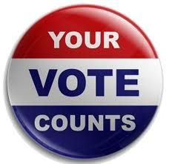

Always vote for principle, though you may vote alone and you may cherish the sweetest reflection that your vote was never lost
- John Quincy Adams

What are some good political sources?
This is a difficult topic to cover as one will never find a completely unbiased political source. It is better to find out where one stands politically, and pick a source that focuses more on their views. This article will cover some of the best sources for different political views.

Tips to picking a reliable source:
“If a site ends in .gov, it is most likely a reliable government web site. Government sites are usually good sources for statistics and objective reports.
Sites that end in .org are usually non-profit organizations. They can be very good sources or very poor sources, so you'll have to take care to research their possible agendas or political biases, if they exist.
Every television and print news source has a web site. To some extent, you can rely on the most trusted news sources, but you should not rely on them exclusively. After all, network and cable news stations are involved in entertainment. Think of them as a stepping stone to more reliable sources”
(http://homeworktips.about.com/od/researchandreference/a/internet.htm)

Conservative Political Sources:
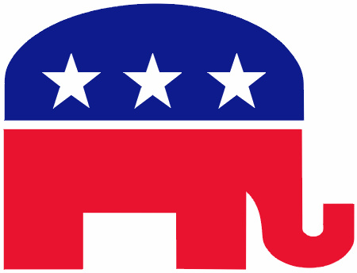
Michelle Malkin- Michelle is a blogger that is a conservative. Her opinions have sparked many debates. She’s a good source because it’s a direct source from another conservative that may share the same views.
National Review Online- The NRW is an online conservative newspaper. The NRW covers and debates about large current political issues.
“The National Review is widely considered one of the most influential conservative publications in the world and as it explains in its "About" page, it constantly aims at providing the "right's take" on political issues facing the world” (http://news.cnet.com/8301-17939_109-10151227-2.html)

Liberal Political Sources:
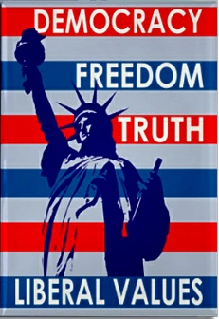
Daily Kos- Daily Kos is another blog site, but this blog site allows others to freely express their opinions about current political issues. Many of the opinions shared on this site are more of liberals, being of which an excellent source for a Liberal.
The Nation- The Nation is another website that is heavily centered on Liberalism. This site is known more for their direct attacks on conservative approaches to political issues.
“The Nation proudly calls itself "the flagship of the left." It should: the publication, which has been operating since 1865, frequently attacks conservative thinkers (a recent blog post pokes fun at conservative pundit, William Kristol, for losing his column in The New York Times op-ed page) and heaps praise on the left” (http://news.cnet.com/8301-17939_109-10151227-2.html)

Campaigning
Often one will see campaigning commercials or campaign signs in their local neighborhood. What do we as American citizens really get out of these videos? These signs? In this article, we will discuss the strategies and techniques candidates use to campaign.


Fliers- Fliers are one of the most common and useful campaign techniques used historically and currently. Fliers can have information of policies the candidate supports, doesn’t support, things the candidate wishes to change, enforce, and laws that the candidate believes should be reviewed. A good flier contains a lot of information about the candidate and what they stand for. A bad flier contains irrelevent information as to why one should vote for this candidate. What it comes down to is if the flier is truly rational or irrational.

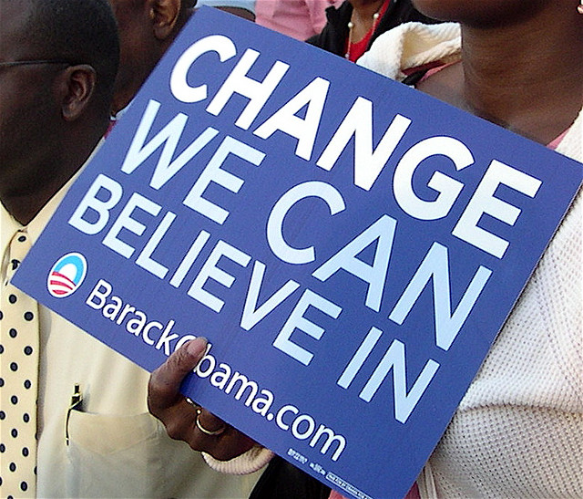
Signs- Signs are the next most used methods as ways to broadcast a candidate’s name. Signs are mostly to recognize the candidate’s name and party. Campaign signs often are red, white, blue, and black. These colors appeal to Americans because they are our nations colors. Mental shortcuts are often taken by irrational voters, and with the colors of the country on a campaign sign, irrations voters assume that the candidate must be a good American to vote for. Another strategy used with the signs is enlarged, bolded font for the candidate’s name. The larger names will appeal more than the smaller names, which will be easier for a voter to remember at the voting booth. Of course, location of the signs are just strategic in a campaign. Sign will often be placed in neighbor hoods, busy traffic areas, heavily populated cities, states, and even in the windows of American’s homes.
Commercials- Commercials are the most obvious method of campaign exposure used to reach Americans. Millions of Americans watch television. Many Americans are guilty of watching a lot more television than they should. 
Candidates take advantage of this and often show campaign commercials to give themselves a good name, state what they stand for, why they should have their vote, and in some cases, the total opposite of all of those about their competitor. Positive and Negative commercials are used to influence American voters. Positive commercials are the most common and usually depict the goodness that voting for the candidate will result.Negative commercials are either a direct attack to the competitor, stating why they shouldn’t be voted for, or a threat of insecurity or more commonly fear that failing to vote for the candidate will result in.

“Just a Thought”

The next time you watch a commercial or read a flier, ask yourself what strategy is being used and how it’s going to influence your vote.

